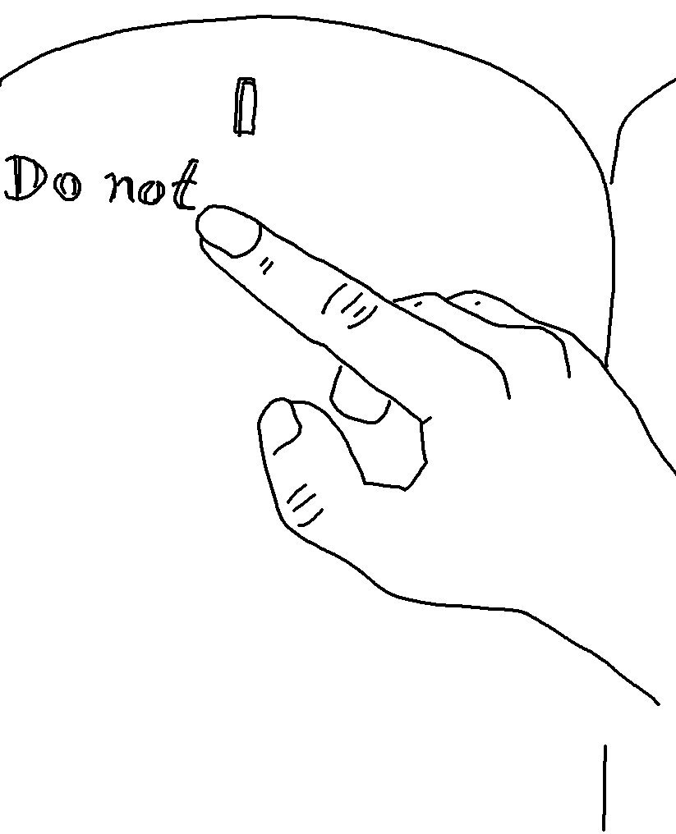
Love means doing what God has commanded us.
2 John 6_{NLT}

